B.K. Jewellers

**Function Requirement Specification (FRS)**

**Document for**

**“Sales management” department.**

Document NO: 001

Date: 07-02-2020

Prepared by:

Group 2

* **Revision History**

|  |  |  |  |
| --- | --- | --- | --- |
| **Revision Number** | **Revision Date** | **Summary of changes** | **Author** |
| **1** | 07/02/2020 | Document made. | Ghanshyam gamit |
| **2** | 18/04/2020 | * **Table of content:** Page numbers added. * (**2.1 &2.2 IMAGE**)**:** Indicators added. * **(2.1 &2.2 all elements):** Button state (active) added. | Rudra soni |
| **3** |  |  |  |
|  |  |  |  |

* **Table of Contents** -

|  |  |  |
| --- | --- | --- |
| Sr.  No. | Content | Page  No. |
| 1. | Introduction |  |
|  | * 1. Objective | 4 |
|  | 1.2 Scope | 4 |
|  |  |  |
| 2. | Functional Description |  |
|  | 2.1 Salesman | 4 |
|  | 2.2 Sales manager | 9 |
|  |  |  |
| 3. | System hardware | 13 |
|  |  |  |
| 4. | Security | 13 |
|  |  |  |
| 5. | Regulatory requirement |  |
|  | 5.1 Accurate record generation | 13 |
|  | 5.2 Timeouts | 14 |
|  | 5.3 Operational system checks | 14 |
|  | 5.4 Electronic signature manifestation | 14 |
|  | 5.5 User password controls | 14 |
|  | 5.5.1 Password expiration | 14 |
|  | 5.6 Additional system controls | 15 |
|  | 5.6.1 Event logging | 15 |
|  | 5.6.2 System access | 15 |
|  | 5.6.3 Input checks | 15 |

1. **Introduction**
   1. Objective:

This is the functional requirement specification (FRS now onwards) for “Sales” functionalities used by sales department of **B.K. Jewellers.**

The FRS is details the capabilities and functions that the software must be capable of and reliably perform functionalities.

* 1. Scope:

This document applies to the “Sales department” of software. The document will address the functions of “Sales department” must be able to successfully perform primary business requirements. The focus is on what the “Sales department” must do.

1. **Function description**
   1. Salesman

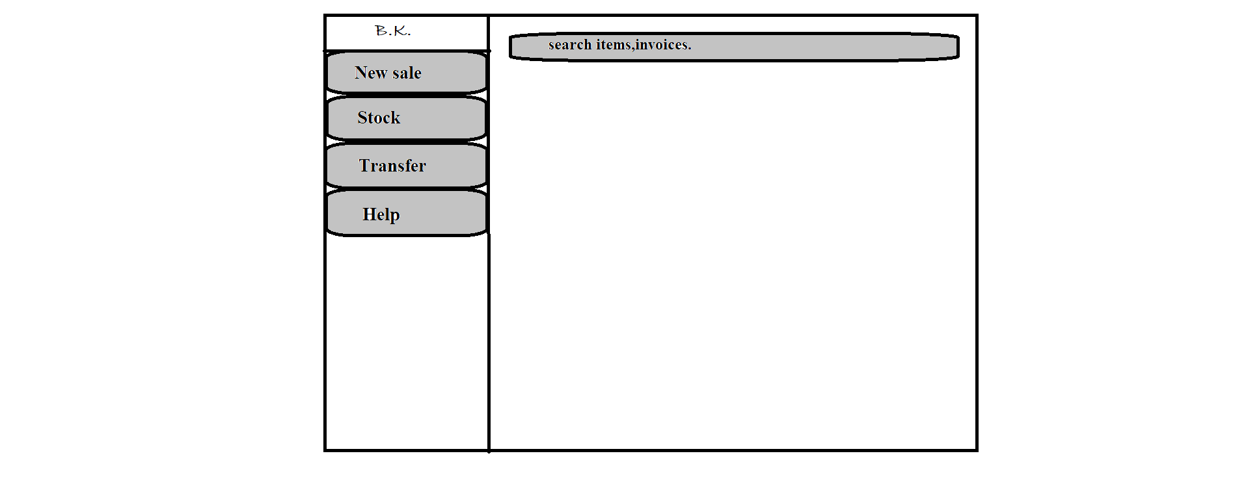

C

D

E

F

B

A

1. Logo

* Type: image
* Use: only for design
* Events: none
* Source: BKlogo.png

1. New sale

* Type: button
* Text on button: New sale
* Background color(Active): gray
* Use: to create a new sale invoice.
* Events:

click:- navigate user to preformatted invoice into editing mode.

Hover:- display information (text) “new invoice.” below mouse arrow.

* Functions:
* Automatic new invoice number generated.
* When button is clicked a preformatted invoice preview will open in editable mode.
* After scanning barcodes full details from database of an item will be displayed in respective fields automatically.
* Automatic GST will be added and final price will appear.
* After clicking submit button placed on below right corner, invoice has been sent to get printed via connected printers.

1. Stock

* Type: button
* Text on button: Stock
* Background color (Active): gray
* Use: used for daily scanning of stock.
* Events:

click:- navigate user to a new window which contains two columns, one is full of available stock list and other is empty which is used for counting.

Hover:- display information (text) “daily stock scanning.” below mouse arrow.

* Functions:
* When clicked user will navigate to a new window which contains two columns side by side, one is full of available stock list and other is empty which is used for counting.
* When a barcode of an item is scanned, it will match the data and transfer that item from right column to right column.
* If any barcode is scanned twice, scanning process will be stopped at that point.
* After completion of scanning user will click submit button placed on bottom right corner.
* When submit button is clicked all data will be stored into database with date and completion time.

1. Transfer

* Type: button
* Text on button: Transfer
* Background color(Active): gray
* Use: to change location of item.
* Events:

click:- navigate user to preformatted location transfer voucher (source: loctransfer.xlsx) into editing mode.

Hover:- display information (text) “location transfer.” below mouse arrow.

* Functions:
* Automatic new voucher number will be generated.
* When button is clicked user will navigate to preformatted location transfer voucher (source: loctransfer.xlsx) into editing mode.
* User will have to add items by scanning barcodes only.
* When a barcode of any item is scanned, the item is shown on right column with its full details submitted on adding to the stock.
* When submit button is clicked a preview of voucher will appear and all scanned items will added to stock of destination location and removed from current location.

1. Help

* Type: button
* Text on button: Help
* Background color(Active): gray
* Use: to acknowledge the user.
* Events:

click:- a help page (source: help.docx)will appear which contains all information of every single step.

Hover:- display information (text) “help.” below mouse arrow.

* Functions:
* When button is clicked help.docx page will appear in full window.

1. Search

* Type: Search bar
* Placeholder:
* Use: search any invoices and items.
* Events:

click:- activate keyboard for input.

* Functions:
* When user click on search bar keyboard will be activated for input.
* When “Enter” button is clicked after any invoice number or item code is entered software will search matching data from database and show all details and last operation done on item in new window.
  1. Sales manager

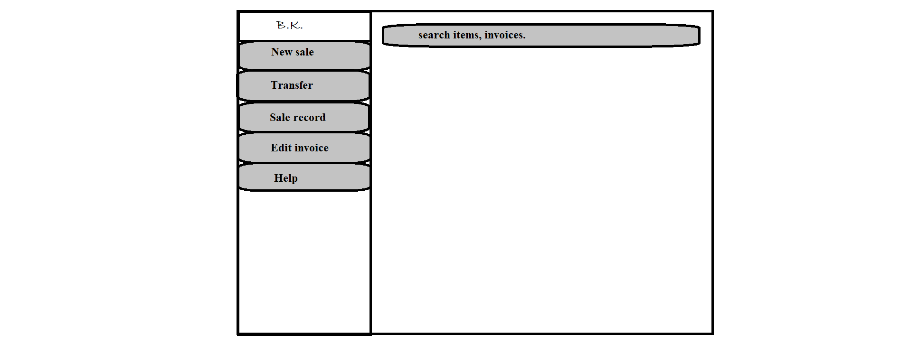

f

e

d

c

b

g

a

1. Logo

* Type: image
* Use: only for design
* Events: none
* Source: BKlogo.png

1. New sale

* Type: button
* Text on button: New sale
* Background color(Active): gray
* Use: to create a new sale invoice.
* Events:

click:- navigate user to preformatted invoice into editing mode.

Hover:- display information (text) “new invoice.” below mouse arrow.

* Functions:
* Automatic new invoice number generated.
* When button is clicked a preformatted invoice preview will open in editable mode.
* After scanning barcodes full details from database of an item will be displayed in respective fields automatically.
* Automatic GST will be added and final price will appear.
* After clicking submit button placed on below right corner, invoice has been sent to get printed via connected printers.

1. Transfer

* Type: button
* Text on button: Transfer
* Background color(Active): gray
* Use: to change location of item.
* Events:

click:- navigate user to preformatted location transfer voucher (source: loctransfer.xlsx) into editing mode.

Hover:- display information (text) “location transfer.” below mouse arrow.

* Functions:
* Automatic new voucher number will be generated.
* When button is clicked user will navigate to preformatted location transfer voucher (source: loctransfer.xlsx) into editing mode.
* User will have to add items by scanning barcodes only.
* When a barcode of any item is scanned, the item is shown on right column with its full details submitted on adding to the stock.
* When submit button is clicked a preview of voucher will appear and all scanned items will added to stock of destination location and removed from current location.

1. Sale record

* Type: button
* Text on button: Sale record
* Background color(Active): gray
* Use: to change location of item.
* Events:

click:- a new window will appear containing list of generated invoices before current date with invoice number and name of customer.

Hover:- display information (text) “sale records.” below mouse arrow.

* Functions:
* When button is pressed, software will collect images of all invoices.
* Excluding those invoices will which are generated on current date.
* The information gathering process will take 5 seconds maximum.
* When the result is ready, it will be displayed in ascending order with respect to generation date (current one should be at top).

1. Edit invoice

* Type: button
* Text on button: Edit invoice
* Background color(Active): gray
* Use: to make changes in submitted invoices.
* Events:

click:- a new window will appear for entering invoice number and after entering invoice number user will have to click on “ok” button placed on bottom-right corner of window.

Hover:- display information (text) “Edit invoices.” below mouse arrow.

* Functions:
* When button is pressed, a new window will appear for entering invoice number.
* After invoice number is entered software will match the number from all invoices submitted in database.
* If match is found, it will be displayed in editing mode else an error massage will pop-us “not found.”.
* If any changes in price, final price will be calculated automatically.

1. Help

* Type: button
* Text on button: Help
* Background color(Active): gray
* Use: to acknowledge the user.
* Events:

click:- a help page (source: help.docx)will appear which contains all information of every single step.

Hover:- display information (text) “help.” below mouse arrow.

* Functions:
* When button is clicked help.docx page will appear in full window.

1. Search

* Type: Search bar
* Placeholder:
* Use: search any invoices and items.
* Events:

click:- activate keyboard for input.

* Functions:
* When user click on search bar keyboard will be activated for input.
* When “Enter” button is clicked after any invoice number or item code is entered software will search matching data from database and show all details and last operation done on item in new window.

1. **System hardware**

The software can run on the minimum standard PC workstation or laptop configuration by **B.K. Jewellers.** This part can be accessible by all PC present in workgroup of organization for “Sales”.

This part of the software does not affect the organization LAN.

1. **Security description**

The sales part is only accessible through the software provided by “BlackSky Systems.” This software or any part of the software does not open from outside the configured environment of **B.K. Jewellers.**

1. **Regulatory requirements**
   1. Accurate record generation:

The functionality meets the following requirements:

* The ability to generate accurate and complete copies of record in both human readable and electronic form is suitable for inspection & review by the agency.
* Users are able to select search queries.
* Users are able to export data through MS Excel sheet.
  1. Timeouts:

The software for “Sales department” will not automatically time-out, it is supposed to run after login till the user logout from the system.

* 1. Operational system checks:

The “Sales department” software uses operational system checks for permitted sequencing of steps and events.

* 1. Electronic signature manifestation:

The software has secure data in system through electronic signatures. Data secured with an electronic signature cannot be edited or deleted unless the signature is removed.

* 1. User password controls:

This software does not allow user to change their passwords. Only the administration has this authority.

5.5.1 Password expiration:

Once the password is created it never expires unless user requested to change it.

* 1. Additional system controls:

5.6.1 Event logging:

It includes system login and logout, as well as attempts failures.

5.6.2 System access:

Access to software must be controlled by user access to the LAN controlled by system identification and password.

5.6.3 Input checks:

When appropriate entries may programmatically checked before being accepted by software.(for example, No negative values accepted for item price.)